WEEK 1

AIM:- To write a Program to stimulate cp command

Description:-

The Command cp is used to copy the contents of one file to another file
Syntax In unix : - cp [source filename] [destination file name]
cp command will overwrite files without asking. If the destination file name already exists, its data will be destroyed.

Algorithm:-

1)Initialize Two File pointers to Identify source and destination file.
2)Initialize Two char arrays which acts as buffer space for Storing the information of the source file to copy . Read the file names using gets() function.
3)Assaign the File pointers using fopen() function.
Note :- Open the Source file in read mode and Destination File in Write Mode.
4)if the fopen(source) returns “NULL” that means the source file doesnot exist so,terminate the entire program.
5)if the sorce file exists , Until we reach the end of the file , we read each character in source file and place that chaacter in destination file.
6)Close Both Files.

Libraries Used:-

Header Files:-
Stdio.h :- This Header file in included for performing basic operations like printing and scanning.
stdlib.h :- stdlib.h is the header of the general purpose standard library of C programming language which includes functions involving memory allocation, process control, conversions and others.

Functions Used:

1)fopen():-
Syntax:-Declaration: FILE *fopen (const char *filename, const char *mode)

fopen() function is used to open a file to perform operations such as reading, writing etc. In a C program, we declare a file pointer and use fopen() as below. fopen() function creates a new file if the mentioned file name does not exist.
FILE *fp;
fp=fopen (“filename”, ”‘mode”);

Where,
fp – file pointer to the data type “FILE”.
Filename – the actual file name with full path of the file.
mode – refers to the operation that will be performed on the file. Example: r, w, a, r+, w+ and a+.
fclose():-
Declaration: int fclose(FILE *fp);
fclose() function closes the file that is being pointed by file pointer fp. In a C program, we close a file as below.
fclose (fp);
gets() :-

Declaration: char *gets (char *string)

gets functions is used to read the string (sequence of characters) from keyboard input.
In a C program, we can read the string from standard input/keyboard as below.

gets (string);

fputc() :-

Declaration: int fputc(int char, FILE *fp)

fputc functions is used to write a character into a file. In a C program, we use fputc() function as below.
returns the character that is written in case of successful write operation else in case of error EOF is returned.

fputc(ch, fp);

where,
ch – character value
fp – file pointer

fgetc():-

Declaration: int fgetc(FILE *fp)

fgetc function is used to read a character from a file.
It reads single character at a time. In a C program, we use fgetc() function as below.

This function returns the number of characters read by the function.
fgetc (fp); where , fp – file pointer

Code :-

#include <stdio.h>
#include <stdlib.h>
int main()
{
char ch, source_file[20], target_file[20];
FILE *source, *target;

printf("Enter name of file to copy\n");
gets(source_file);

source = fopen(source_file, "r");

if (source == NULL)
{
printf("Press any key to exit...\n");
exit(EXIT_FAILURE);
}

printf("Enter name of target file\n");
gets(target_file);

target = fopen(target_file, "w");

while ((ch = fgetc(source)) != EOF)
fputc(ch, target);

printf("File copied successfully.\n");

fclose(source);
fclose(target);

return 0;
}

Output:-

Case 1:-
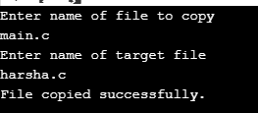

Case 2:-

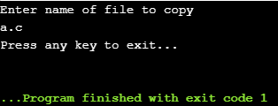
Observations:-

cp command works on three principal modes of operation and these operations depend upon number and type of arguments passed in cp command :

1.Two file names : If the command contains two file names, then it copy the contents of 1st file to the 2nd file. If the 2nd file doesn’t exist, then first it creates one and content is copied to it. But if it existed then it is simply overwritten without any warning. So be careful when you choose destination file name.

cp Src_file Dest_file

2.One or more arguments : If the command has one or more arguments, specifying file names and following those arguments, an argument specifying directory name then this command copies each source file to the destination directory with the same name, created if not existed but if already existed then it will be overwritten, so be careful !!.

cp Src_file1 Src_file2 Src_file3 Dest_directory

3.Two directory names : If the command contains two directory names, cp copies all files of the source directory to the destination directory, creating any files or directories needed. This mode of operation requires an additional option, typically R, to indicate the recursive copying of directories.
cp -R Src_directory Dest_directory

WEEK 2
AIM :- To Write a C program to Stimulate ls -l command

Description:-

To list files in a specific directory, pass the path to the directory to the ls command.

The default output of the ls command shows only the names of the files, which is not very informative. When the long listing format is used the ls -l command will display the following file information:

The file type
The file permissions
Number of hard links to the file
File owner
File group
File size
Date and Time
File name

The -l option causes ls to print files in long listing format.

Algorithm:-

Input :-n/a
Output :- Detailed list of files and directories present
Description:-The ls – l is used for long listing the information about files and directories present

Libraries used:-
Stdio.h :- This Header file in included for performing basic operations like printing and scanning.
Sys/stat.h:- This header file contains functions and structures required to know the status of a file
fileStat Structure:- this is a stat structure which composes of stmode ,s_isdir ,st.size.., variables
to know about the file information
dirent.h: this header file is included to get the dirent structure to point to a file.
Time.h:- ctime():- this method is used to get the time of modification on a file.
Grp.h:-this header files contains the properties required for a group ,Structure Group is being used here
Pwd.h:- this header file is included to know about the present working users on a file at that particular moment.

Code :-

#include<stdio.h>
#include<sys/stat.h>
#include<stdlib.h>
#include<dirent.h>
#include<time.h>
#include<grp.h>
#include<pwd.h>
int main(int argc, char **argv){
struct passwd *pw;
struct group *gp;
DIR *mydir;
char *c;
int i;
struct dirent *myfile;
struct stat fileStat;
mydir=opendir(".");
stat(".",&fileStat);
while((myfile=readdir(mydir))!=NULL)
{
stat(myfile->d_name,&fileStat);
printf( (S_ISDIR(fileStat.st_mode)) ? "d" : "-");
printf( (fileStat.st_mode & S_IRUSR) ? "r" : "-");
printf( (fileStat.st_mode & S_IWUSR) ? "w" : "-");
printf( (fileStat.st_mode & S_IXUSR) ? "x" : "-");
printf( (fileStat.st_mode & S_IRGRP) ? "r" : "-");
printf( (fileStat.st_mode & S_IWGRP) ? "w" : "-");
printf( (fileStat.st_mode & S_IXGRP) ? "x" : "-");
printf( (fileStat.st_mode & S_IROTH) ? "r" : "-");
printf( (fileStat.st_mode & S_IWOTH) ? "w" : "-");
printf( (fileStat.st_mode & S_IXOTH) ? "x" : "-");
printf(" ");
printf("%d ",fileStat.st_nlink);
pw=getpwuid(fileStat.st_uid);
printf("%s ",pw->pw_name);
gp=getgrgid(fileStat.st_gid);
printf("%s ",gp->gr_name);
printf("%4d ",fileStat.st_size);
c=ctime(&fileStat.st_mtime);
for(i=4;i<=15;i++)
printf("%c",c[i]);
printf(" ");
printf("%s\n",myfile->d_name);
}
closedir(mydir);
return 0;
}

Outputs:-

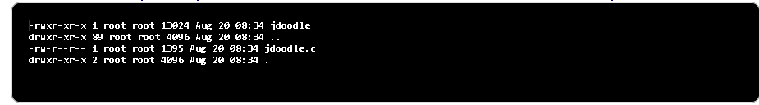

Observation:-

ls -l shows file or directory, size, modified date and time, file or folder name and owner of file and its permission.

WEEk 3

Aim : to demonstrate fork() system call using c programming

Description:-

Fork system call use for creates a new process, which is called child process, which runs concurrently with process (which process called system call fork) and this process is called parent process. After a new child process created, both processes will execute the next instruction following the fork() system call. A child process uses the same pc(program counter), same CPU registers, same open files which use in the parent process.

Libraries Used :-

sys/types.h:-
This header file is included to utilize fork() command.

Fork():-

i/p:- none
o/p:-
Negative Value: creation of a child process was unsuccessful.
Zero: Returned to the newly created child process.
Positive value: Returned to parent or caller. The value contains process ID of newly created child process.

Code:-

#include <stdio.h>
#include <sys/types.h>

#define MAX_COUNT 200

void ChildProcess(void); /* child process prototype */
void ParentProcess(void); /* parent process prototype */

void main(void)
{
pid_t pid;

pid = fork();
if (pid == 0)
ChildProcess();
else
ParentProcess();
}

void ChildProcess(void)
{
int i;

for (i = 1; i <= MAX_COUNT; i++)
printf(" This line is from child, value = %d\n", i);
printf(" *** Child process is done ***\n");
}

void ParentProcess(void)
{
int i;

for (i = 1; i <= MAX_COUNT; i++)
printf("This line is from parent, value = %d\n", i);
printf("*** Parent is done ***\n");
}

Output:-

Case 1:- max_count=10
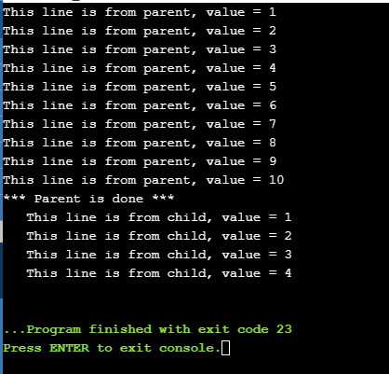

Case 2:- max_count=6
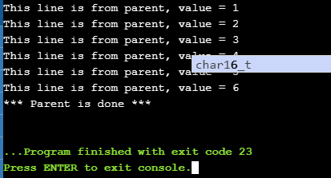

Observation:-
It takes no parameters and returns an integer value. Below are different values returned by fork().
Negative Value: creation of a child process was unsuccessful.
Zero: Returned to the newly created child process.
Positive value: Returned to parent or caller. The value contains process ID of newly created child process.

The fork command duplicates the process , it maintains a copy until the process is terminated. It does not terminate the previous process to start a new process.It creates a new process which is a copy of the calling process. That means that it copies the caller's memory (code, globals, heap and stack), registers, and open files. The calling process returns from fork() with the pid of the newly created process (which is called the "child" process. The calling process is called the "parent" process).

AIM:-Program to Demonstrate EXEC() family commands.

Algorithm:-
The working Of exec is
Current process image is overwritten with a new process image.
- New process image is the one you passed as exec argument
- The currently running process is ended
- New process image has same process ID, same environment, and same file descriptor (because process is not replaced process image is replaced)
- The CPU stat and virtual memory is affected. Virtual memory mapping of the current process image is replaced by virtual memory of new process image.

Libraries Used:-
Stdio.h :- This Header file in included for performing basic operations like printing and scanning.
Stdlib.h :- stdlib.h is the header of the general purpose standard library of C programming language which includes functions involving memory allocation, process control, conversions and others.
Unistd.h :- unistd.h is the C/C++ header file that is your code's entry point to various constant, type and function declarations that comprise the POSIX operating system API.

Description:-

exec family commands:-
int execlp( const char *file, const char *arg, ... );

int execle( const char *path, const char *arg, ..., char *const envp[] );
int execvp( const char *file, char *const argv[] );
int execve( const char *file, char *const argv[], char *const envp[] );

exec is used when the user wants to launch a new file or program in the same process.The return type of these functions is Int. When the process image is successfully replaced nothing is returned to calling function because the process that called it is no longer running. But if there is any error -1 will be returned. If any error is occurred an errno is set.
In the syntax:
- path is used to specify the full path name of the file which is to be executes.
- arg is the argument passed. It is actually the name of the file which will be executed in the process. Most of the times the value of arg and path is same.
- const char* arg in functions execl(), execlp() and execle() is considered as arg0, arg1, arg2, …, argn. It is basically a list of pointers to null terminated strings. Here the first argument points to the filename which will be executed as described in point 2.
- envp is an array which contains pointers that point to the environment variables.
- file is used to specify the path name which will identify the path of new process image file.
- The functions of exec call that end with e are used to change the environment for the new process image. These functions pass list of environment setting by using the argument envp. This argument is an array of characters which points to null terminated String and defines environment variable.

Execvp :-Using this command, the created child process does not have to run the same program as the parent process does. The exec type system calls allow a process to run any program files, which include a binary executable or a shell script

Execlp:-
The execlp system call duplicates the actions of the shell in searching for an executable file if the specified file name does not contain a slash (/) character. The search path is the path specified in the environment by the PATH variable. If this variable isn’t specified, the default path ":/bin:/usr/bin" is used.
The execlp system call can be used when the number of arguments to the new program is known at compile time.

Execle:-
Like all of the exec functions, execle replaces the calling process image with a new process image. This has the effect of running a new progam with the process ID of the calling process. Note that a new process is not started; the new process image simply overlays the original process image. The execle function is most commonly used to overlay a process image that has been created by a call to the forkfunction.

Code:-

execlp:-
Like all of the exec functions, execlp replaces the calling process image with a new process image. This has the effect of running a new program with the process ID of the calling process. Note that a new process is not started; the new process image simply overlays the original process image. The execlp function is most commonly used to overlay a process image that has been created by a call to the forkfunction.

#include <unistd.h>
#include <stdio.h>
#include <stdlib.h>
int main(void)
{
execlp("ls", "ls", "-l", NULL);
perror("Return from execlp() not expected");
exit(EXIT_FAILURE);
}

execle:-
#include <unistd.h> // execv()
#include <stdio.h> // perror()
#include <stdlib.h> // EXIT_SUCCESS, EXIT_FAILURE

void main() {
int ret;
char *env[] = { "HOME=/usr/home", "LOGNAME=home", (char *)0 };
ret = execle ("/bin/ls", "ls", "-l", (char *)0, env);

}

execvp:-

#include <unistd.h> // execvp()
#include <stdio.h> // perror()
#include <stdlib.h> // EXIT_SUCCESS, EXIT_FAILURE

int main(void) {
char *const cmd[] = {"ls", "-l", NULL};
execvp(cmd[0], cmd);
perror("Return from execvp() not expected");
exit(EXIT_FAILURE);
}

execv:-
#include <unistd.h> // execv()
#include <stdio.h> // perror()
#include <stdlib.h> // EXIT_SUCCESS, EXIT_FAILURE

int main() {
char *const argv[] = {"/bin/ls", "-l", NULL};
execv(argv[0], argv);
perror("Return from execv() not expected");
exit(EXIT_FAILURE);
}
execve:-

#include <unistd.h> // execv()
#include <stdio.h> // perror()
#include <stdlib.h> // EXIT_SUCCESS, EXIT_FAILURE

void main() {
int ret;
char *cmd[] = { "ls", "-l", (char *)0 };
char *env[] = { "HOME=/usr/home", "LOGNAME=home", (char *)0 };
ret = execve ("/bin/ls", cmd, env);
}

Output:-

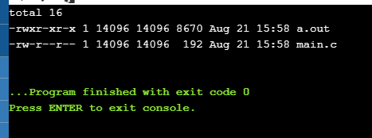

Observation:-
The exec family of functions replaces the current running process with a new process. It can be used to run a C program by using another C program. It comes under the header file unistd.h.

